<https://drive.google.com/drive/folders/12fELMR50SOxOt63tEmyoE9dl7k6RlebV?usp=sharing>

|  |  |
| --- | --- |
| Traditional Chinese | English |
| Phonak CROS Belong | |
| 微型耳背式 (312/13電池) | Behind-the-ear (Battery 13 or 312) |
| V 適合單側聽損人士使用  H0 -米黃色  P1-砂漠黃  P3 -檀木色  P4 -深栗色  P5 –香檳金  P6 –銀灰色  P7 –石墨灰  P8 –絲絨黑  T7 –山雪白  phonak-audeo-marvel-mr-r-hearing-aid-cost-colours-best - eardeals.com.au  產品規範 | V Suitable for single-sided deafness users  H0 - Beige  P1- Sand Beige  P3 - Sandalwood  P4 - Chestnut  P5 – Champagne  P6 – Silver Gray  P7 – Graphite Gray  P8 – Velvet Black  T7 – Alpine White  Technical Specification |
| 功能 V | Features |
| Belong 平台技術  雙耳語音串流技術™ | Belong Platform Technology  Binaural VoiceStream Technology™" |
| 包括 V | Included: |
| 助聽器防潮保養套件 60粒免費電池 2年維修保養 | Hearing aid maintenance kit  60 free hearing aid batteries  2 years warranty |
| HEARGO升級服務 V | HEARGO upgraded service |
| 1次免費上門跟進調較 3個月內升級換機 | 1 free home visit service for adjustment/ fine-tuning Upgrade device within 3 months |
| Belong 平台技術 | Belong Platform Technology |
| Belong™技術及雙耳語音串流技術™讓裝置在嘈吵環境下能鎖定語音，令聲音更清晰  T:\Audio\HearGo\Heargo Website content\CROS.tif | Powered by Phonak Belong™ technology, this product features our signature Binaural VoiceStream Technology™ for excellent speech understanding in noise. |
| 雙耳語音串流技術™  應用峰力獨創雙耳語音串流技術，CROS B能將來自劣耳的語音以無線傳遞方式處送至好耳助聽器。這令CROS B能在嘈吵的環境下鎖定語音，語音清晰度能提升3.8 dB，讓你能輕鬆進行對話。  T:\Audio\HearGo\Heargo Website content\CROS-2.tif | Binaural VoiceStream Technology™  Using our signature exclusive Binaural VoiceStream Technology™, CROS B wirelessly transfers sound from the client’s worse ear to the Belong hearing aid on the better-hearing side. Thanks to this proven binaural beamforming technology, CROS B has the ability to create a very narrow beamforming pattern, resulting in a 3.8 dB improvement in speech intelligibility in noise, compared to no Binaural VoiceStream Technology™. |
| HEARGO專業助聽器驗配服務 | HEARGO professional hearing aids fitting service |
| 1次免費上門跟進調較; 3個月內升級換機 | 1 free home visit service for adjustment/ fine-tuning  Upgrade device within 3 months. |
| <<同一平台其他型號>> | Other models in the series |
| 回到產品列表-> | Back to list of products |
| 立即預約(button) -> | Book now |

Other comments:

差mouseover effect，了解更多

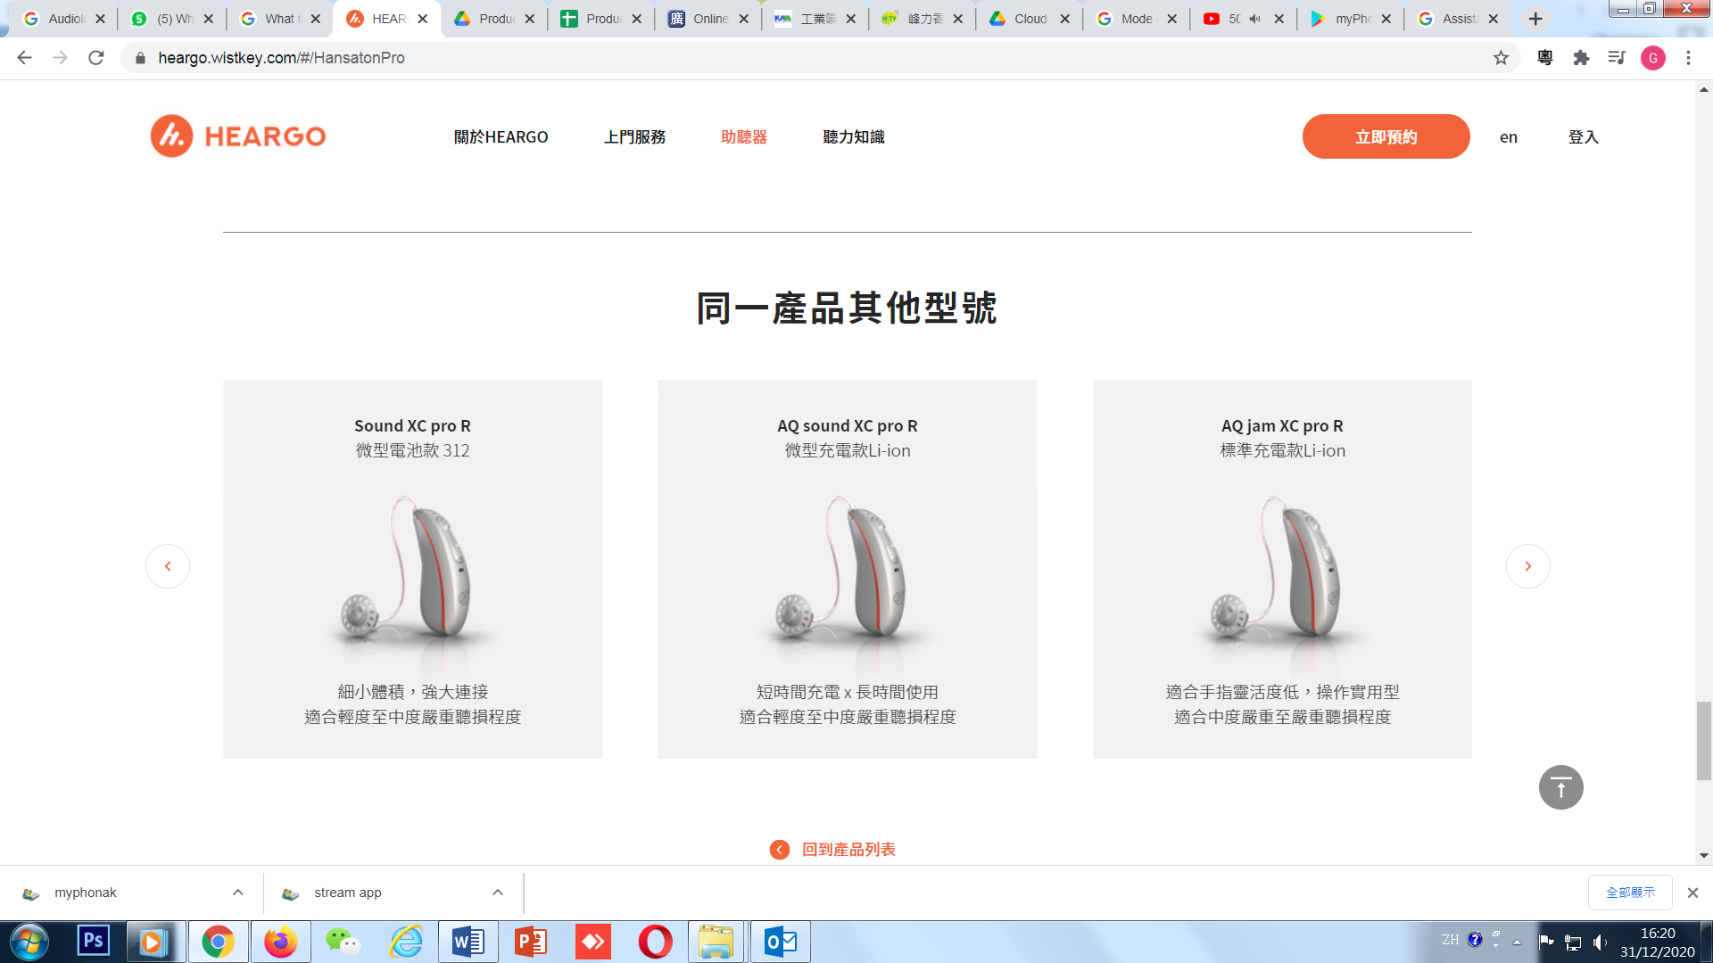

Commented:　Cherry Eugena Vincent Alanna Charmaine (KAM)